**National Textile University, Faisalabad**



**Department of Computer Science**

|  |  |
| --- | --- |
| **Name:** | Rida Khan |
| **Class:** | BSCS – 5B |
| **Registration No:** | 23-NTU-CS-1087 |
| **Course Name:** | Embedded IOT Systems |
| **Submitted To:** | Sir Nasir Mahmood |
| **Submission Date:** | 25th Oct, 2025 |

**Assignment 1 – Question 3**

**Code (Handwritten)**

**Task A:**

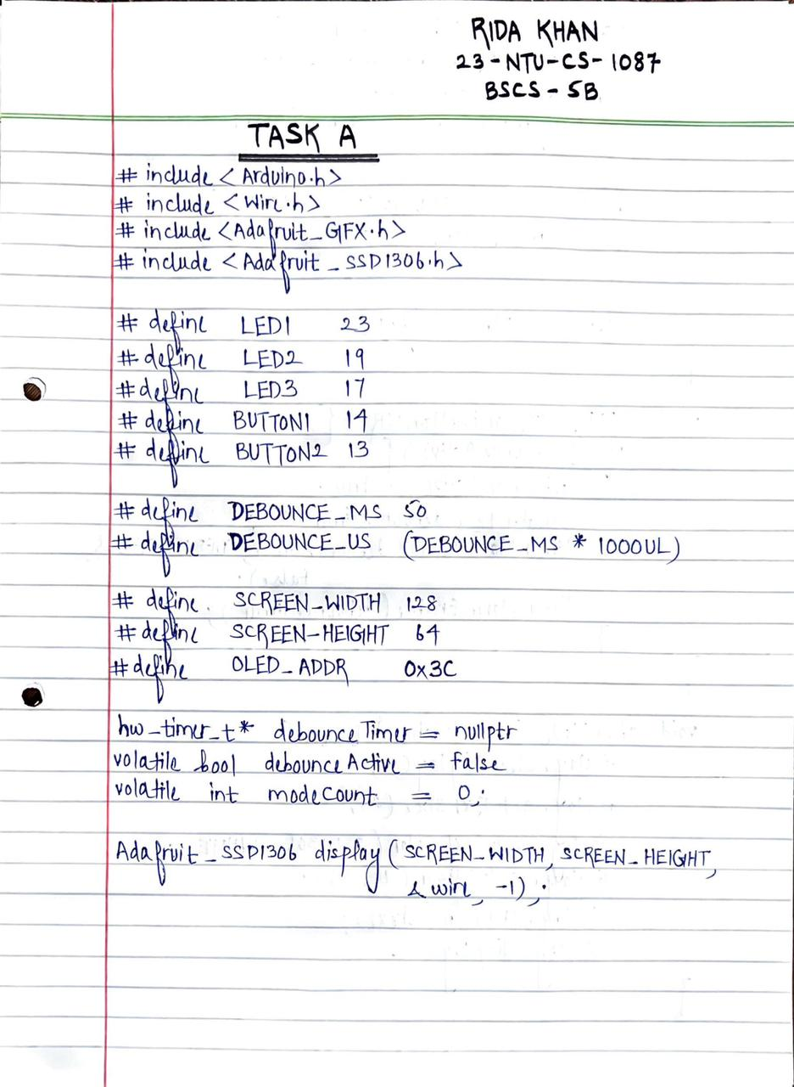

**Wokwi Diagram (Drawn & Labelled)**

**Pin Map**

|  |  |
| --- | --- |
| **Component** | **ESP32 Pin** |
| LED 1 (+) | GPIO 23 |
| LED 1 (-) | GND |
| LED 2 (+) | GPIO 19 |
| LED 2 (-) | GND |
| LED 3 (+) | GPIO 17 |
| LED 3 (-) | GND |
| Button 1 (Mode) | GPIO 14 |
| Button 2 (Reset) | GPIO 13 |
| Buzzer (+) | GPIO 27 |
| Buzzer (-) | GND |
| OLED SDA | GPIO 21 |
| OLED SCL | GPIO 22 |
| OLED VCC | 3.3V |
| OLED GND | GND |

**Pictures of Kit**

**Task A:**

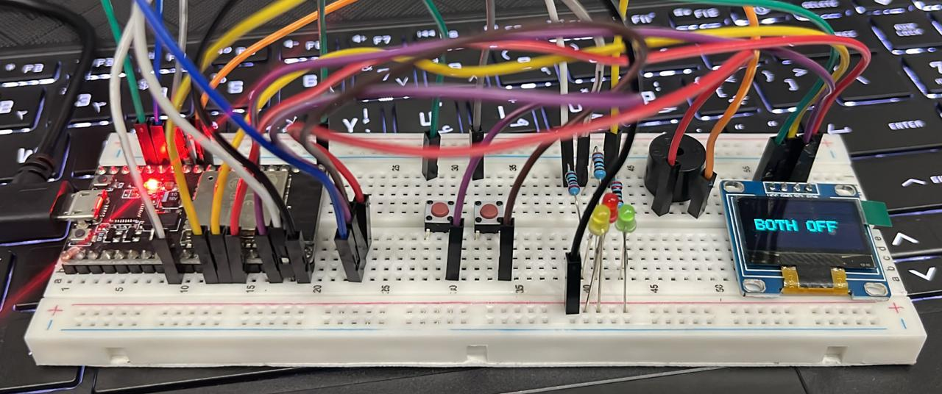

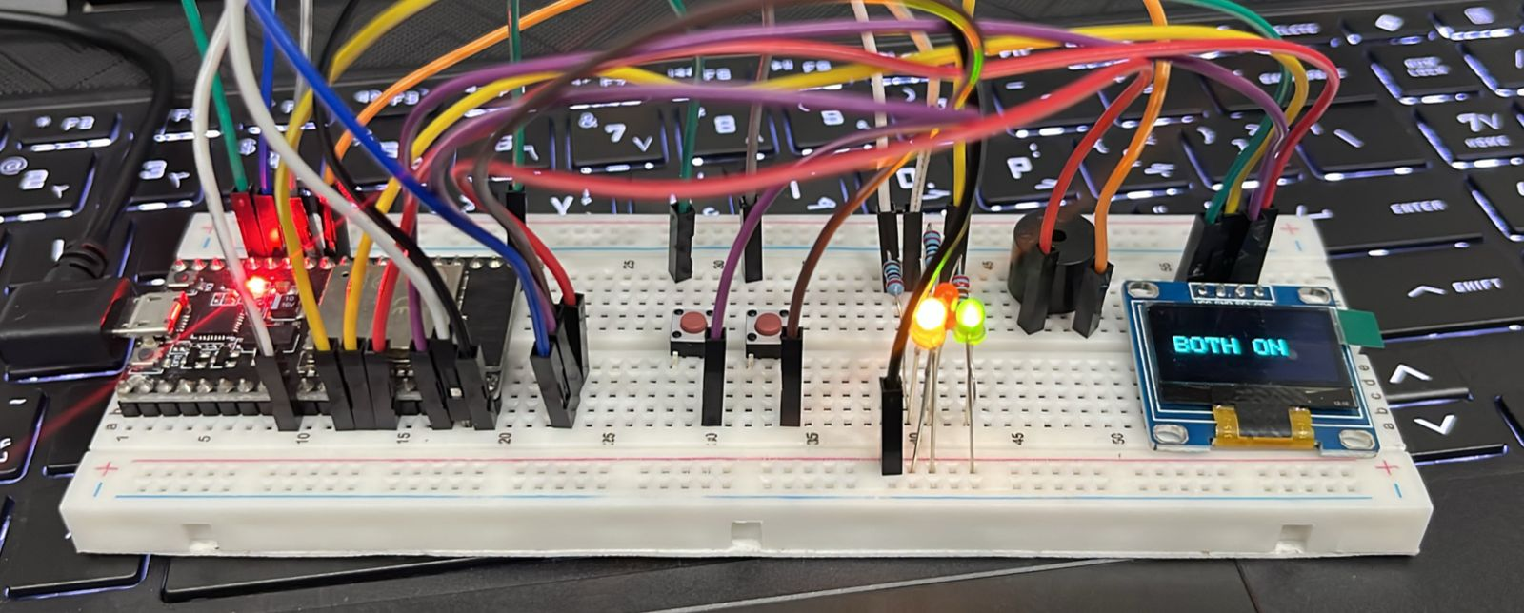

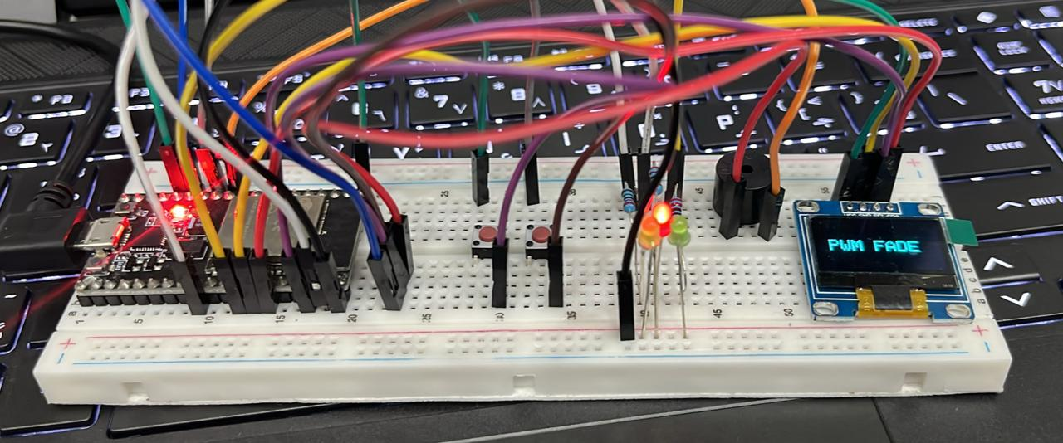

**Wokwi Link**

**Task A:** https://wokwi.com/projects/445525900687682561